

University of Engineering & Technology Mardan
Department of Computer Software Engineering

Submitted By | Umar Hayat
Semester | 6th, Spring 2026
Registration No | 23MDSWE274
Batch | 06
Subject | HCI Lab
Submitted To | Dr. Hamid Ullah
Lab Task # 08

Lab Task 1: Brainstorming
Who will use the app (Target Audience): The primary target demographic consists of university students, specifically those in demanding, screen-heavy disciplines like Computer Software Engineering. This group frequently experiences a highly sedentary lifestyle due to long hours spent coding, debugging, and writing extensive lab reports.
Information needed from users: To build an effective app for this demographic, data must be gathered across three main categories:
- Physical Context: What kind of physical space do they have available?
- Time Constraints: What are their realistic windows of free time on a typical weekday?
- Ergonomic Baseline: Are they experiencing physical side effects of prolonged sitting, such as lower back pain or neck stiffness?
Main points we want to know from users:
- Fitness Goals: Are they looking for quick ways to boost mental alertness, correct posture, or simply manage academic stress?
- Daily Routine: How do they manage time between heavy subjects, and do they prefer short morning stretches or late-night routines?
- Problems: Is their primary barrier a severe lack of time, cognitive overload after labs, or the financial inability to afford gym memberships?
- Preferences: Do they prefer quick, "no-equipment" workouts that can be done next to a study desk?
Lab Task 2: Design The Consent Form
Informed Consent The purpose of this survey is to understand your daily habits and preferences to help design a new fitness app. It will take approximately 2 minutes to complete. Your participation is completely voluntary, and all responses will be kept strictly private and anonymous. The data will be used exclusively for this academic interface design project. By proceeding to the next section and submitting your answers, you consent to participate in this survey.
Lab Task 3: Designing the Survey
Section 1: Basic Information
- What is your current academic standing? 1st Year, 2nd Year, 3rd Year, 4th Year, Graduate Student
- What is your primary living situation during the semester? * University Hostel/Dorm, Commuting from Home, Off-campus Apartment
Section 2: User Habits
- On average, how many days per week do you currently engage in deliberate physical activity? * 0 days (Sedentary), 1-2 days, 3-4 days, 5+ days
- On average, how many hours per day do you spend sitting at a desk or looking at a screen? * Less than 4 hours, 4 to 6 hours, 7 to 9 hours, 10+ hours
Section 3: Opinions
- Which of the following features would make a fitness app most useful for your specific daily routine? * Micro-workouts (Guided routines under 10 minutes)
  - "Desk-Friendly" posture correction and stretching guides
  - No-equipment, small-space workout routines
  - Gamified progress tracking (Streaks, badges)
  - Smart notifications (Reminders to stand up that sync with study breaks)
- How much does the cost of a fitness application or gym membership influence your decision to exercise? * 1 (Not a factor at all) to 5 (The absolute biggest deciding factor)
Section 4: Open-Ended Question
- What is the biggest challenge or frustration you face when trying to maintain a consistent physical activity routine? * Description: If you face several challenges, please describe the one that impacts you the most.
Lab Task 4: Conduct Your Survey
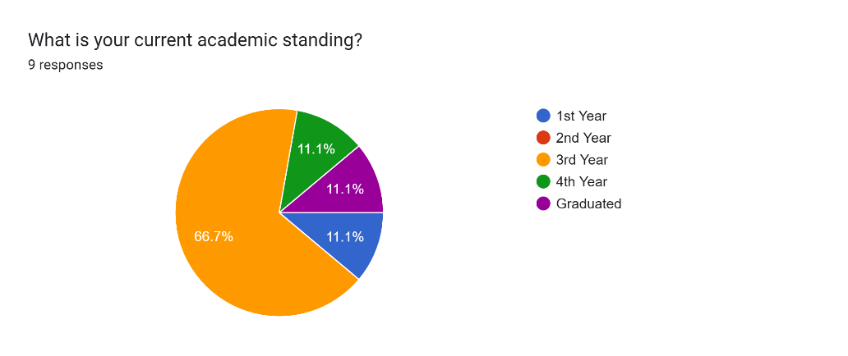
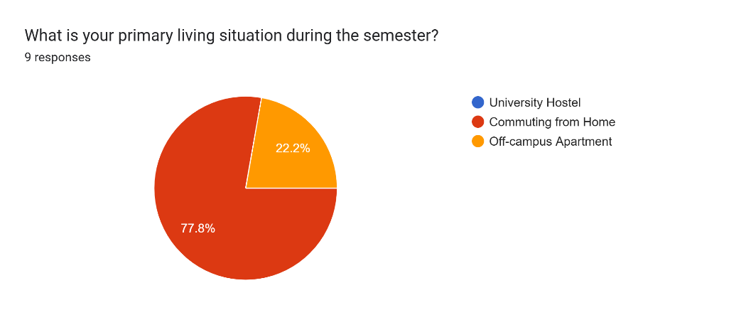

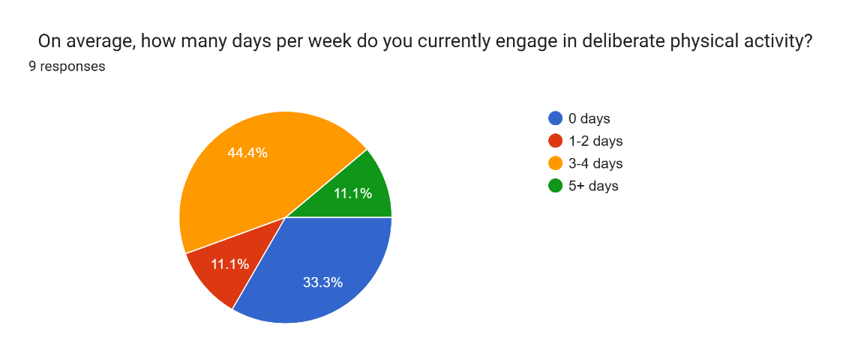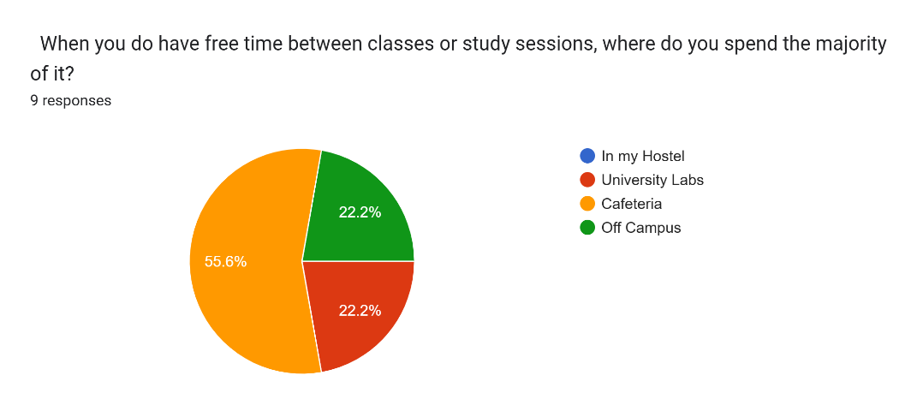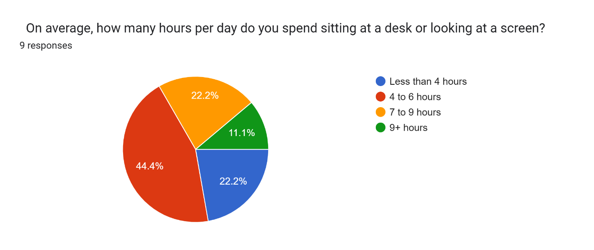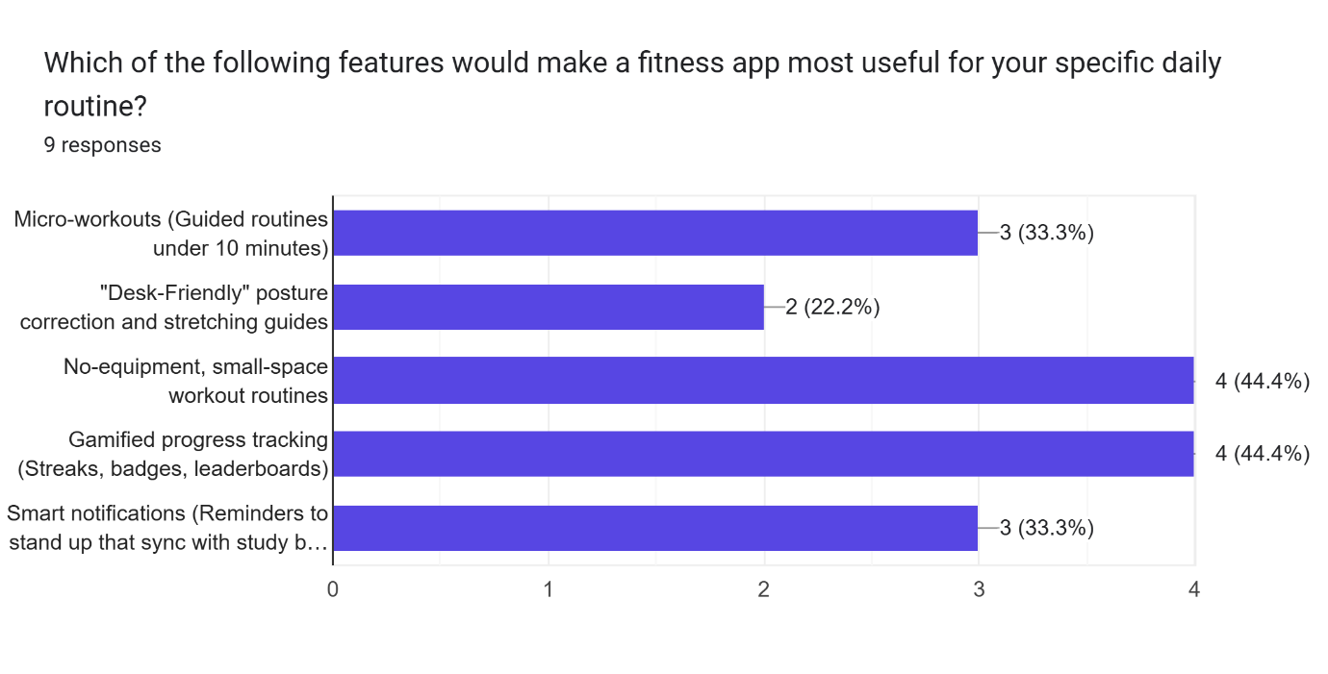
Lab Task 5: Report Your Results
Important Findings from the Data:
- Severe Time Constraints: The majority of respondents spend over 7 hours daily looking at screens. Open-ended responses revealed that finding a continuous 45–60 minute block for traditional exercise is their biggest hurdle.
- High Price Sensitivity: On the 1-to-5 scale regarding price influence, most respondents selected a 4 or 5, indicating that expensive premium subscriptions are a major barrier to entry.
- Space Limitations: Users living in hostels prefer exercises that require absolutely zero equipment and minimal floor space.
- Preference for Functional Movement: In the feature prioritization section, "Desk-Friendly posture correction" and "Micro-workouts" were highly requested, showing a need for functional routines to combat academic burnout.
Suggested Improvements or Features for the App:
- "Study Break" Micro-Routines: Implement a feature that generates 5-minute, equipment-free stretching routines specifically designed to be done next to a desk to combat physical stiffness and cognitive fatigue.
- Freemium Model: Because price sensitivity is high among students, the core application must remain free. Monetization should be restricted to advanced, highly specialized metrics or diet plans.
- Posture Correction Focus: Include a dedicated track within the app focused entirely on alleviating "tech neck" and lower back pain, directly addressing the ergonomic problems caused by long coding and study sessions.

Github Repository:
https://github.com/umarhayat1651/HCI-Labs

